Grade Assist RTT – CGEA1.3

Functional Description

The purpose of the Grade_Assist _RTT is to inform the driver that the automatic transmission is in the Grade Assist mode.

The Grade_Assist _RTT correlates the PtDrvMde_D_Stat signal and the Operational_Mode to illuminate or extinguish the Grade Assist RTT.

The Grade_Assist _RTT shall provide an iconic representation that will illuminate or extinguish to inform the driver transmission will not shift into overdrive gear on an automatic transmission.

This section describes the RTT function and sets a flag that is used by the Message Center display (See Message Center Section for details of Message Display Algorithm).

Important: PtDrvMde_D_Stat signal same value is also used to activate the Tow Haul RTT. To date no programs have or are expected to have both the Grade Assist and Tow Haul features. If this ever occurs, however, an internal supplier bit or EOL configuration will have to be added.

Interfaces

Interface Context Diagram (I/O Block Diagram)
Figure 1. Grade Assist RTT Indication
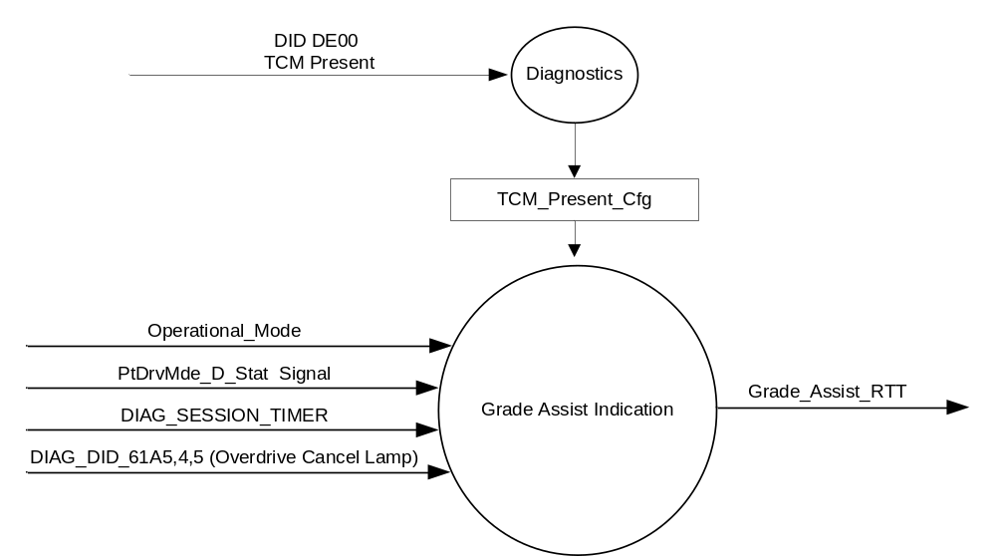

Inputs
      - INTERNAL:
            - DIAG_SESSION_TIMER
            - Operational_Mode
            - DIAG_DID_61A5,4,5 (Overdrive Cancel Lamp)

      - MUX message on the CAN Bus from TCM

- PtDrvMde_D_Stat Signal
Signal Name | Size  (bits) | Detail | Units | Res. | Offset | State  Encoded | Min. | Max.
PtDrvMde_D_Stat | 3 |  | SED | 1 | 0 |  | 0  (0x0) | F  (0xF)
 |  | Normal |  |  |  | 0x0
 |  | Sport |  |  |  | 0x1
 |  | SnowWet |  |  |  | 0x2
 |  | TowHaulGradeAssist |  |  |  | 0x3
 |  | NotUsed1 |  |  |  | 0x4
 |  | NotUsed2 |  |  |  | 0x5
 |  | NotUsed3 |  |  |  | 0x6
 |  | NotUsed4 |  |  |  | 0x7
 |  | NotUsed5 |  |  |  | 0x8
 |  | NotUsed6 |  |  |  | 0x9
 |  | NotUsed7 |  |  |  | 0xA
 |  | NotUsed8 |  |  |  | 0xB
 |  | NotUsed9 |  |  |  | 0xC
 |  | NotUsed10 |  |  |  | 0xD
 |  | NotUsed11 |  |  |  | 0xE
 |  | Faulty |  |  |  | 0xF

Outputs
Grade_Assist_RTT, which is used to control the state of the Reconfigurable Telltale

Function/Performance

Operational Modes

Mode | Differentiating Vehicle Conditions
Sleep Mode | Grade_Assist_RTT Inactive
Limited Mode | Grade_Assist_RTT Inactive
Normal Mode | Grade_Assist_RTT Active/Inactive
Crank Mode | Grade_Assist_RTT Active/Inactive

The above table references the setting of the RTT flag as per this section. However, the actual RTT display operational modes are displayed in the Message Center section of this SPSS.

Voltage Levels

Refer to the Cluster Features table located in the Operational Modes and Voltage Range Strategies Section in this SPSS

Human-Machine Interface

Visual

Indicator Graphics / Display Format
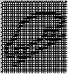
Passenger Car SUV

Pixel Definition

For actual symbol definition see pixel definition section in the message center section.
The pixel representation is based upon the symbol definition database # TBD of the 03-0685 ARL requirement.

Indicator Color Coordinates

Amber - Reference SDS IL-0017/IS-0379

Indicator Characteristics

Pixel Display in Message Center Display – GRADE ASSIST RTT for Car (#27) & GRADE ASSIST RTT for SUV (#28)

Audio

None

Switch Control Logic

Not Applicable

System Accuracy

The state of the Grade_Assist_RTT shall change within 100msec of a state change as indicated in the state matrix reference 1.3.5.1 Subsystem Algorithm Flowchart/ State Diagram

Operation: Performance and Functional

Subsystem Algorithm Flowchart / State Diagram

- State Matrix for Grade_Assist_RTT Flag
Operational_Mode | DIAG_SESSION_TIMER | DIAG_DID_61A5,4,5 (Overdrive Cancel Lamp) | PtDrvMde_D_Stat Signal | Grade_Assist_RTT
Normal or Crank | Not Active | X | TowHaulGradeAssist (0x3) | Active
Normal | Not Active | X | Missing as per 1.4.1 | Inactive
Normal | Active | Not Received | TowHaulGradeAssist (0x3) | Active
Normal | Active | Not Received | Missing as per 1.4.1 | Inactive
Normal | Active | ON (0x1) | X | Active
All Other Cases |  |  |  | Inactive
X = Don’t Care
Not Received = The state when a DIAG_SESSION_TIMER is active and the DID has not been received.

Operation Description (supports algorithm flowchart /state diagram)

- Grade_Assist_RTT shall reflect signal state within 100 mS of receipt of PtDrvMde_D_Stat Signal.
- The actual RTT display operational modes are displayed in the Message Center Section of this SPSS.

Function Safety Classification (EMC)

Class B

Memory Storage

Parameter Name | Description | Value at  Battery Connect | Value at  Module Wake-up
Grade_Assist_RTT | Used to control the state of the RTT | Not Active (0x0) | Not Active (0x0)
PtDrvMde_D_Stat signal | CAN signal sent from the TCM | Normal (0x0) | Normal (0x0)
TCM_Present_Cfg | Encoded indicator of feature presence controlled via CAN at EOL at VO plant. | Use Stored Value | Use Stored Value
DIAG_DID_61A5,4,5 (Overdrive Cancel Lamp) | Warning Lamp Status 2, byte 4, bit 5 (Overdrive Cancel Lamp) | 0 (0x0) | 0 (0x0)
Operational_Mode | 4 state indicator for cluster operational mode | Limited | Limited or Normal or Crank

Parameter Name | Description | Value at Battery Connect | Value at Module Wake-up
DIAG_SESSION_TIMER | Timer used to time-out a diagnostic session | Not Active | Not Active

Prove Out

No

Reconfigurable Telltale

Yes

Message Center Msg

See Message Center Section for displaying RTT based upon state of RTT flag
W161 is associated with the Grade_Assist_RTT status flag.

Error Handling

Missing Message Strategy
The signals will be declared missing as per the Diagnostics section of this SPSS.

DTCs states and history will be determined as per the Diagnostics section of this SPSS.

Depending on the B&A configuration, only one of the missing message DTCs shall be logged given the proper input conditions.

Diagnostics

Self Test

None

Engineering Test Mode

Reference section “Dealer / Engineering Test Mode (ETM)”

Part II Performance

Supported Diagnostic DIDs (Service $22 and $2F)
Number | DID / Common ID Name | DID Type
DIAG_DID_61A5,4,5 (Overdrive Cancel Lamp) | Warning Lamp Status 2, byte 4, bit 5 (Overdrive Cancel Lamp) | Bit Mapped

Supported Diagnostic Trouble Codes (DTCs)
DTC | Description
C10000 | Lost communication with ECM/PCM
C10100 | Lost communication with TCM

DID DE00
Block  Num | Block Description | Size (bits) | Type | Byte(s) | Bits | State: Description | "0" | "1" | Default | Comments/  Information
PACKETED BLOCKS
$00 | Option Content (B&A) | * | 1 | * | * | TCM Present | Disabled (PCM) | Enabled | Enabled
*Byte and bit location to be identified in Part II Specification for this cluster

Reference Specification

IS-0001 WARNINGS/INDICATORS/DISPLAYS PROVEOUT
IS-0046 INSTRUMENTATION MATERIAL RESISTANCE TO CLEANING
IS-0052 OPERATING VOLTAGES - FUNCTIONAL/PERFORMANCE
IS-0069 FUNCTIONAL IMPORTANCE CLASS
IS-0324 WINDSHIELD & OTHER REFLECTIONS
IS-0327 WARNING INDICATOR EVALUATION
IS-0329 FLICKERING OF LAMPS
IS-0379 NORTH AMERICAN WARNINGS AND INDICATORS STRATEGY

IL-0017 TELLTALE AND INTERIOR ILLUMINATION COLOR
IL-0021 CRAFTSMANSHIP - DISPLAYS
IL-0023 CLARITY/LEGIBILITY/READABILITY
IL-0025 INTERIOR ILLUMINATION INTENSITY
IL -0027 VISUAL CONTRAST
IL -0043 OPERATIONAL ENVIRONMENT FUNCTIONALITY
IL -0045 COLOR
IL -0047 TELLTALE; INDICATOR AND DISPLAY LIGHT INTENSITY
IL -0048 ILLUMINATION ACCEPTABILITY

03-0661 PLACEMENT: CONTROL AND DISPLAY LOCATIONS
03-0662 PLACEMENT: LOGICAL GROUPING FUNCTION AND USAGE
03-0664 PLACEMENT: DOWN VISION TO COMPONENTS WITH HIGH VISUAL DEMAND
03-0665 PLACEMENT: EXPECTED LOCATIONS OF CONTROLS AND DISPLAYS VDS
03-0670 INTERIOR VISIBILITY
03-0671 INTERIOR VISIBILITY: REFLECTIONS FROM COMPONENTS & SURFACES
03-0672 INTERIOR VISIBILITY: REFLECTIONS IN DISPLAYS
03-0673 INTERIOR VISIBILITY: VISUAL OBSCURATIONS
03-0674 INTERIOR VISIBILITY: ILLUMINATION CONTROLS / DISPLAYS
03-0675 INTERIOR VISIBILITY: VEILING GLARE
03-0677 INTERIOR VISIBILITY: SUNLIGHT WASHOUT
03-0681 IDENTIFICATION: CHARACTER AND SYMBOL SIZE
03-0682 IDENTIFICATION: LEGIBILITY
03-0685 IDENTIFICATION: SYMBOLS, ABBREV FOR CONTROL
03-0721 LOGIC OF OPERATION: OPERATIONAL STEREOTYPES
03-0722 LOGIC OF OPERATION: INTERPRETATION
03-0723 LOGIC OF OPERATION: USE OF SYSTEMS WITH VISUAL DISPLAYS

Revision History

SPSS Module Revision History

Revision Level | Name | Change Description | Date
1.0 | V. Patel | Updated for CGEA 1.3 based on CGEA STSS v1.0  Section 1.2.2 – Removed table referencing the HS-CAN message that contains the input signal.  Section 1.3.5 – Added a row to capture missing message action in table 1.1  Section 1.4 – Rewritten. Deleted references of specific missing message flags and timer.  Section 1.5.3 – Deleted DTC logging criteria from the table. | 4/12/2010
2.0 | J.Blatchford | This update changes the activating signal from TrnShifMde_D_RqDrv to PtDrvMde_D_Stat. If a program uses TrnShifMde_D_RqDrv signal for the Grade Assist feature then use v1.0 of this STSS.  - 1.1: Added paragraph stating same signal and signal value is also used to illuminate the Tow Haul RTT. If a program is equipped with both Tow Haul and Grade Assist this STSS will have to be updated to protect for that.  - Changed TrnShifMde_D_RqDrv to PtDrvMde_D_Stat throughout document.  - Table 1.0: Replaced prior table with proper signal.  - Table 1.1: updated signal and signal value/detail. Also corrected missing to missing as per 1.4.1.  Changes highlighted in yellow. | 5/21/15

